Welcome students and parents,

We are excited to welcome you to the French Jewrney Vacation Summer program, we here at Grant Language Academy will be working with the French Jewrney team to provide the Academic English component of the program. You will have an amazing time during the program, and we will provide you with Academic English skills that you can use as you move forward in your academic life.

We have assembled an amazing team of professional educators to ensure you receive the best American English skills. The classes will run between two and a half and three hours daily, Monday through Friday during your stay. The French Jewrney team will endure that you are safe and have loads of fun during your stay. We are excited about working with you this summer.

Please complete the pre-program assessment, so we can place you in the correct level for maximum success and enjoyment. The pre-program assessment is designed to measure your American English Academic level, there is no failing score. Follow the instructions for each section of the exam. Download the word document, and save it with your first name, last name, and exam date. Once the exam is complete, please email it to me and the French Jewrney team. The exam should take between thirty and sixty minutes to complete.

Our director: Reginald Grant, MS Ed., Teacher, Author, and Speaker
Seventeen years as a California Certificated English teacher
State of California CASHEE, California State High School Exit, the development team for the English section (2011)
State of California ELPAC, English Language Proficiency Assessments for California (ELPAC) development team on 2015, 2016,2017, middle and high school team.
(MS Ed.) Master’s in Education with an emphasis in curriculum and instruction (TESOL) Teachers of English to Speakers of Other Languages.
Sincerely,
Reginald Grant, MS Ed., reginaldreggiegrant@gmail.com

Follow the instructions for each section of the exam. Download the word document, and save it as: your first name, last name, and exam date. Once the exam is complete, please email it to me (reginaldreggiegrant@gmail.com) and the French Jewrney team (isaac@fjweb.org). The exam should take between thirty and sixty minutes to complete.

STUDENT NAME
DATE OF BIRTH:
GRADE IN SCHOOL 2022:
EMAIL ADDRESS:
PHONE:
PARENTS NAMES:
CONTACT EMAIL:
CONTACT PHONE:

Part 1: Subject and predicate worksheet
Identify the subject and the predicate in the following sentences.
Subject = what the sentence is about
Predicate = what is said about the subject
A: Highlight the Subject in Yellow and the Predicate in RED
1. The sun was shining brightly.
2. The dogs were barking loudly.
3. The pretty girl was wearing a blue frock.
4. My younger brother serves in the army.
5. The man and his wife were working in their garden.
6. My mother and my aunt are trained, classical dancers.
7. You don’t have to wait for me.
8. We will no longer tolerate this.
9. The little tree was covered with needles instead of leaves.
10. A rich merchant was passing by the shoemaker’s window.

Part 2: Reading and Response A
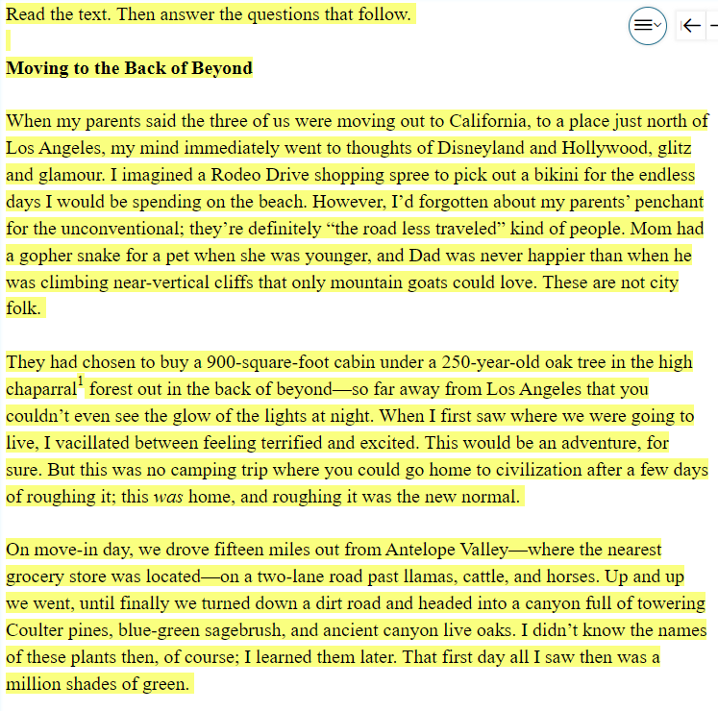
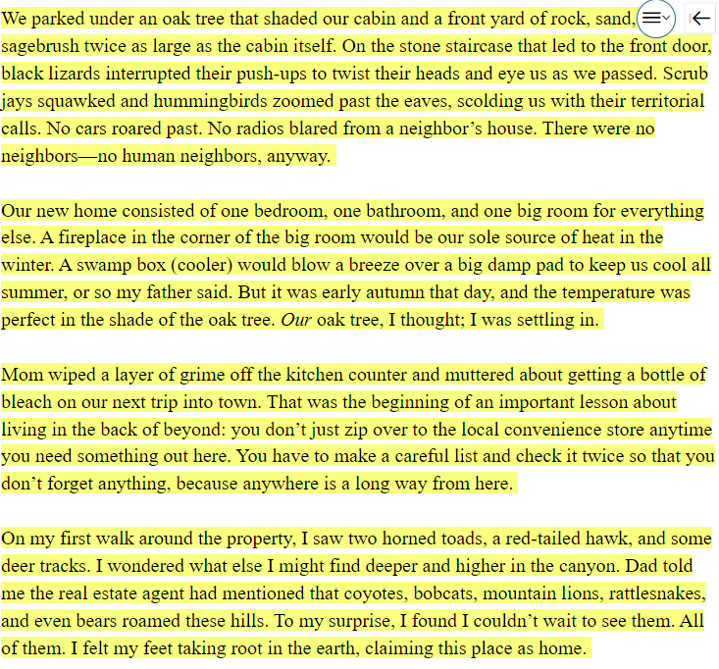
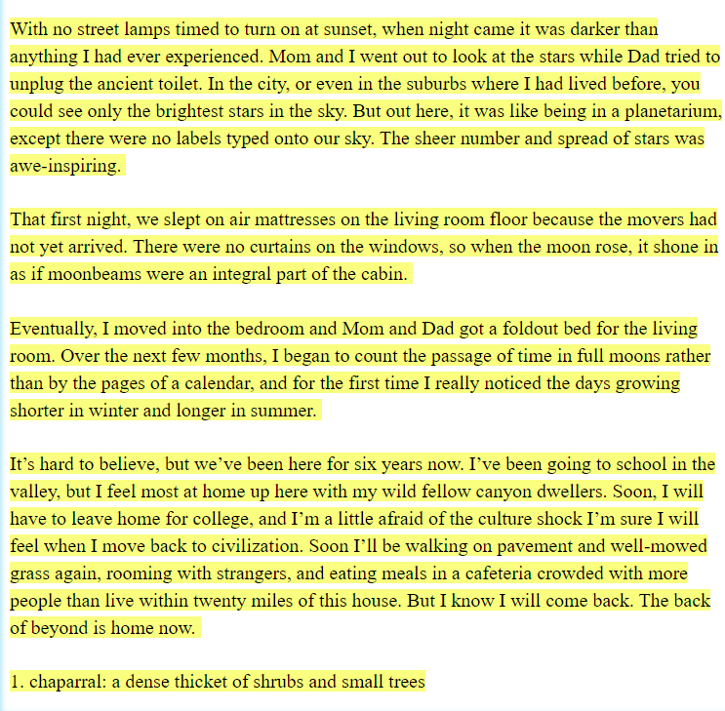

The reader can conclude that the narrator is open to living at the “back of beyond” and accepts er/is new life:
Write a paragraph (four or more) sentences that support that conclusion.

Part 2: Reading and Response B
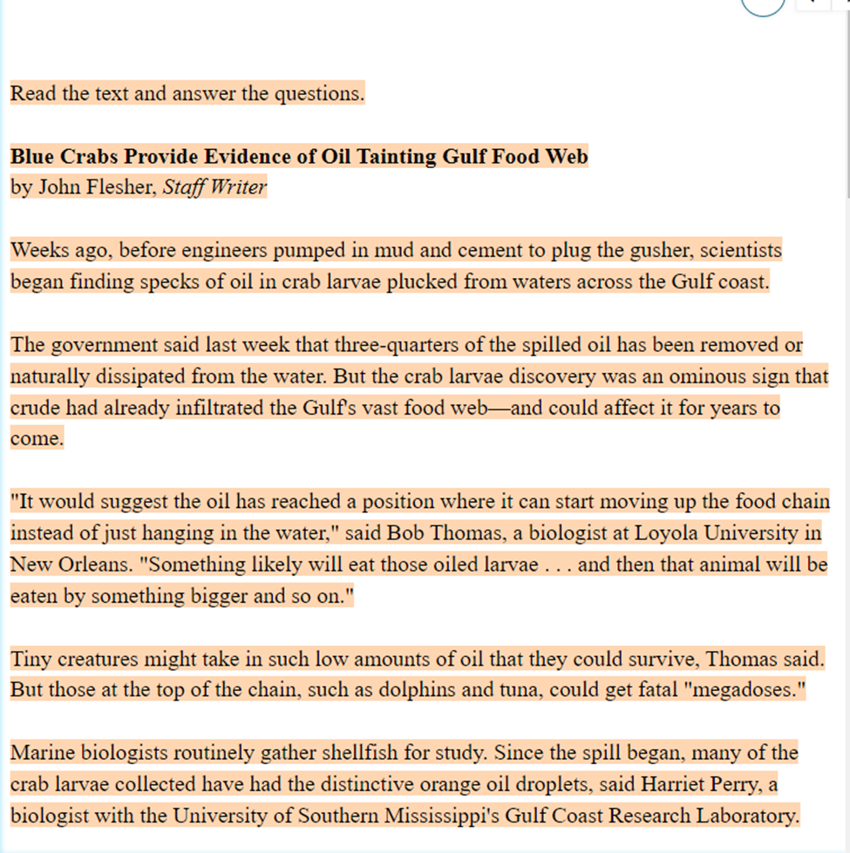
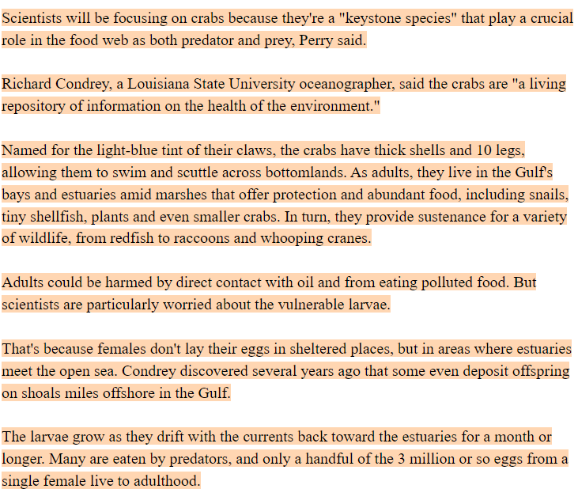
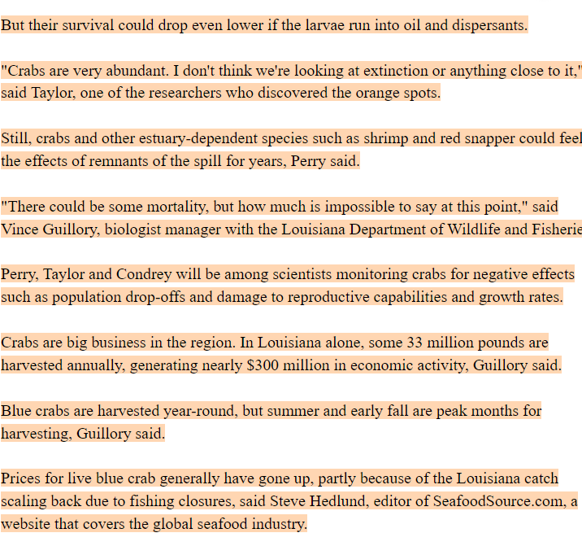
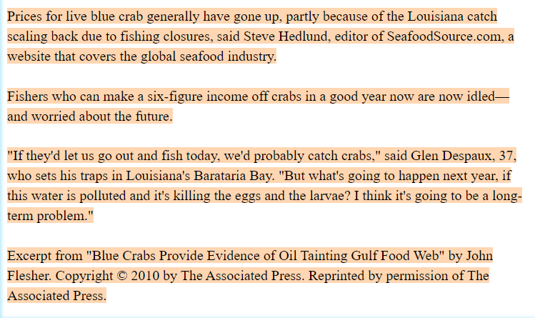
Response 1:
Summarize the authors’ point about why scientists are monitoring the blue crab population so closely. Support your summary using key evidence from the text.

Part 3: Reading and Response C
Read then answer by choosing the correct sentences letter.
- Having a best friend to confide in can bring a positive effect on our emotional health. An evening out with the closest friend may be the best guarantee of a good time. In fact, our best friend can prevent us from developing serious psychological problems such as depression and anxiety. Best friendship evolves with time - we cannot go out and pick our best friend. We become friends with people who share common interests - at school or through hobbies, for example. Best friends have usually known each other for years and stuck together through good and bad times. If you haven't got one, perhaps you are being too distant from people, or focusing too much on your work.

Question 1: A best friend can ___________.
A give us a healthy life
B go out with us in the evening
C spend much time finding
D share joy and sadness with us

- Having a best friend to confide in can bring a positive effect on our emotional health. An evening out with the closest friend may be the best guarantee of a good time. In fact, our best friend can prevent us from developing serious psychological problems such as depression and anxiety. Best friendship evolves with time - we cannot go out and pick our best friend. We become friends with people who share common interests - at school or through hobbies, for example. Best friends have usually known each other for years and stuck together through good and bad times. If you haven't got one, perhaps you are being too distant from people, or focusing too much on your work.
Question 2: Close friends need to ___________.

A study at the same school
B have the same interests
C pursue the same hobbies
D spend time together

- Having a best friend to confide in can bring a positive effect on our emotional health. An evening out with the closest friend may be the best guarantee of a good time. In fact, our best friend can prevent us from developing serious psychological problems such as depression and anxiety. Best friendship evolves with time - we cannot go out and pick our best friend. We become friends with people who share common interests - at school or through hobbies, for example. Best friends have usually known each other for years and stuck together through good and bad times. If you haven't got one, perhaps you are being too distant from people or focusing too much on your work.
Question 3: According to the passage, __________.

A it takes a lot of time to make close friendships
B we can go out and choose a good friend easily
C best friends have good and bad times
D It's very difficult to make lasting friendships

- Having a best friend to confide in can bring a positive effect on our emotional health. An evening out with the closest friend may be the best guarantee of a good time. In fact, our best friend can prevent us from developing serious psychological problems such as depression and anxiety. Best friendship evolves with time - we cannot go out and pick our best friend. We become friends with people who share common interests - at school or through hobbies, for example. Best friends have usually known each other for years and stuck together through good and bad times. If you haven't got one, perhaps you are being too distant from people, or focusing too much on your work.
Question 4: The word "one" in the last paragraph refers to ___________.

A good time
B bad time
C a friendship
D a close friend

- Having a best friend to confide in can bring a positive effect on our emotional health. An evening out with the closest friend may be the best guarantee of a good time. In fact, our best friend can prevent us from developing serious psychological problems such as depression and anxiety. Best friendship evolves with time - we cannot go out and pick our best friend. We become friends with people who share common interests - at school or through hobbies, for example. Best friends have usually known each other for years and stuck together through good and bad times. If you haven't got one, perhaps you are being too distant from people, or focusing too much on your work.

Question 5: Which of the following sentences is not mentioned?
A Which of the following sentences is not mentioned?
B the ties of close friendship will never be broken.
C An unsociable person may not have a close friend.
D Friendships need time to develop.

Part 4: Speaking - Read Aloud 1
Read the passage and record yourself reading it aloud, attach the video.
Making Popcorn Fran asked her father to help her make popcorn. “There are some microwave pouches in the cabinet over the refrigerator,” her father said. “Dad,” Fran moaned softly. “I want to make real popcorn, with real kernels and oil in a pan. I’ll even get out all the things we need, and clean up after,” she said. The ‘clean up after’ part was the clincher. Her father agreed. Fran found a large pan with a cover, some vegetable oil, and the popping corn. First, her father turned on the burner and adjusted the flame. Then he poured oil in the pan. When the oil was hot enough, Fran poured some corn into the pan and carefully placed the cover on top. After a minute, the corn began to pop inside the pan. Then Fran said to her father, “Listen to all the noise! Now I know why it’s called popcorn. It smells fantastic!” Fran's father poured the popcorn into a bowl. He melted some butter and poured it on top. “See, this is the real stuff. Butter! Not like 2 14 24 25 36 52 65 69 82 94 108 121 135 150 154 165 180 Fluency 22 ©2016 Henry Anker the fake stuff that they use in most movie theaters.” Fran rolled her eyes a bit, then smiled, and then added some salt. Fran and her father took the popcorn to the sofa and put the large bowl between them to share. Fran walked over to the shelf of DVDs and picked out her favorite movie, Matilda. Her dad smiled. He knew Fran had seen the movie about a hundred times, and he had watched it several times with her, too. Fran’s dad said, “You know, even though I’ve seen this movie a bunch of times, it’s still fun to watch, because every time I watch it, I notice things I didn’t before.” Fran smiled again. These were special times with her dad.

Part 5: Listening
Three soundtracks can be accessed at
https://www.grantlanguageacademy.com/2022-pretest
Listen and write two sentences about each conversation.

